**Synchronization**

Synchronization point is nothing but time interface between Tool  and  Application build. Generally Synchronization point is to give waiting  time to the tool  before executing next step in Test script.

Different methods in QTP for Synchronization:  
  
1. Wait statements.  
2. Exist Statements.  
3. Sync Method (Only for WEB).  
4. Inserting Synchronization points.  
5. Increasing Tool default synchronization time.

**Wait Statements:**

Wait statements is used when we want QTP to  wait  for  specified time, so that AUT completes its current operations.Wait (n)  statement waits for specified *'n' seconds.* Wait() statement without specifying the seconds will make QTP  wait up  to maximum time, even though operations is  completed.

**Syntax Wait** Seconds, [Milliseconds]

**Exist Statements:**

We can enter Exist statements to instruct QuickTest  to  wait  for  a window to  open or an object to appear. Exist statements return a boolean value indicating whether or not an object currently exists.

**Example**

Dialog("Login").WinEdit("Agent Name:").**Set** "sourabh"   
Dialog("Login").WinEdit("Password:").SetSecure "56b1da5e302cc5f7049534899b019189bcd883e9"  
**Do** **while** Dialog("Login").WinButton("OK").Exist=**false**  
**wait** 2  
**loop**  
Dialog("Login").WinButton("OK").Click   
Window("Flight Reservation").ActiveX("MaskEdBox").Type "061216"   
Window("Flight Reservation").WinComboBox("Fly From:").**Select** "Frankfurt"  
Window("Flight Reservation").WinComboBox("Fly To:").**Select** "London" Window("Flight Reservation").WinButton("FLIGHT").Click Window("Flight Reservation").Dialog("Flights Table").WinList("From").Activate "13572   FRA   10:24 AM   LON   11:09 AM   SR     $165.50"  
Window("Flight Reservation").WinEdit("Name:").**Set** "sou"  Window("Flight Reservation").WinButton("Insert Order").Click

**Inserting Synchronization points(wait property())**:

Adding a synchronization point instructs QTP to pause the test until an object property  achieves the value specified.

**Example**

Dialog("Login").WinEdit("Agent Name:").**Set** "ghvvggv"   
Dialog("Login").WinEdit("Password:").SetSecure "56b1fa862121ecca74ce18441c8ac9f22ff90614"  Dialog"Login").WinButton("OK").WaitProperty "text", "Ok", 10000 Dialog("Login").WinButton("OK").Click

**Difference between wait and wait property**

The main difference between wait and wait property is in wait program have to wait for specific time no matter what condition is fulfill but in wait property uft wait until the specific object is find

The below dialog box enables to insert a Wait Property statement to synchronize test.

[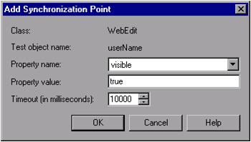](http://2.bp.blogspot.com/-olCcJy3ndas/UYE9QKrxjtI/AAAAAAAAACo/0saFjv_hK8s/s1600/Picture1.png)

**Increasing Tool default synchronization time**

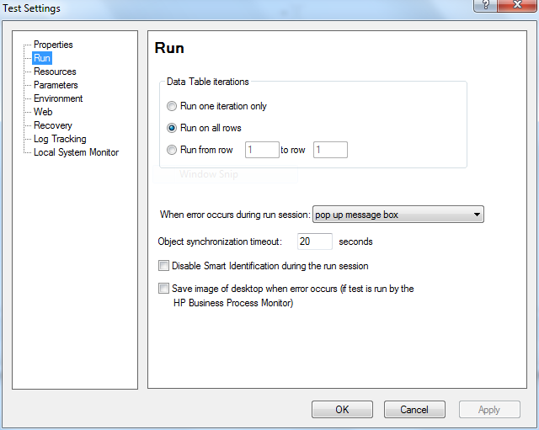

**Sync Method**

Waits **for** the browser **to** complete current navigation.

Systemutil.Run "iexplore.exe","http:\\www.gmail.com"  
Browser("title:=Gmail: Email from Google").Sync  
Browser("title:=Gmail: Email from Google").Page("title:=Gmail: Email from Google") . WebEdit ("name:=Email").**Set**  "qtpworld.com"  
Browser("title:=Gmail: Email from Google").Page("title:=Gmail: Email from Google").WebEdit ("name:=Passwd").**Set**  "qtp"  
Browser("title:=Gmail: Email from Google").Page("title:=Gmail: Email from Google").WebButton ("name:=Sign in").Click